**Python paper solution**

**1)to create main window we cal use ------ methode**

**2)in tkinter pack method is uded to-----**

**3)----method is use to set dimention of tkinter windeow**

**4)tkinter is used to create___application**

**5)what is widget?**

**🡪**there are various widgets like button, canvas, checkbutton, entry, etc. that are used to build the python GUI applications.

**6)__command used for check tkinter library**

**7)tkinter for standard __ library for python**

**8)Explain tkinter window?**

**🡪**The Tkinter window is the **foundational element** of the Tkinter GUI. Tkinter window is a**container in which all other GUI elements(widgets) live**.

win = Tk()

Copy

Yes, we use the Tk() function to create our Tkinter app window in which all the other components are added.

from tkinter import *

win = Tk()

# run the app window

win.mainloop()

Let us now cover a basic example where we will create a Basic GUI Application using properties like **title** and **geometry**.

top-level window (root) having a frame with a**title bar**and **control box** with the minimize and close buttons, and a**client area to hold other widgets**.

a separate viewing area on a computer display screen in a system that allows multiple viewing areas as part of a graphical user interface ( GUI ). Windows are managed by a windows manager as part of a windowing system . A window can usually be resized by the user.

**9)Explain tkinter pack() method**

**🡪**• The pack() widget is used to organize widget in the block.

• The positions widgets added to the python application using the pack() method can be controlled by using the various options specified in the method call.

• However, the controls are less and widgets are generally added in the less organized manner.

**Syntax**: widget.pack(options)

• A list of possible options that can be passed in pack() is given below.

1. expand: If the expand is set to true, the widget expands to fill any space.

2. Fill: By default, the fill is set to NONE. However, we can set it to X or Y to determine whether the widget contains any extra space.

3. side: It represents the side of the parent to which the widget is to be placed on the window.

**Example:**

from tkinter import *

parent = Tk() redbutton = Button(parent, text = "Red", fg = "red")

redbutton.pack( side = LEFT)

blackbutton = Button(parent, text = "Black", fg = "black")

blackbutton.pack( side = RIGHT )

bluebutton = Button(parent, text = "Blue", fg = "blue")

bluebutton.pack( side = TOP )

greenbutton = Button(parent, text = "Green", fg = "green")

greenbutton.pack( side = BOTTOM)

parent.mainloop()

**10)Explain tkinter widget**

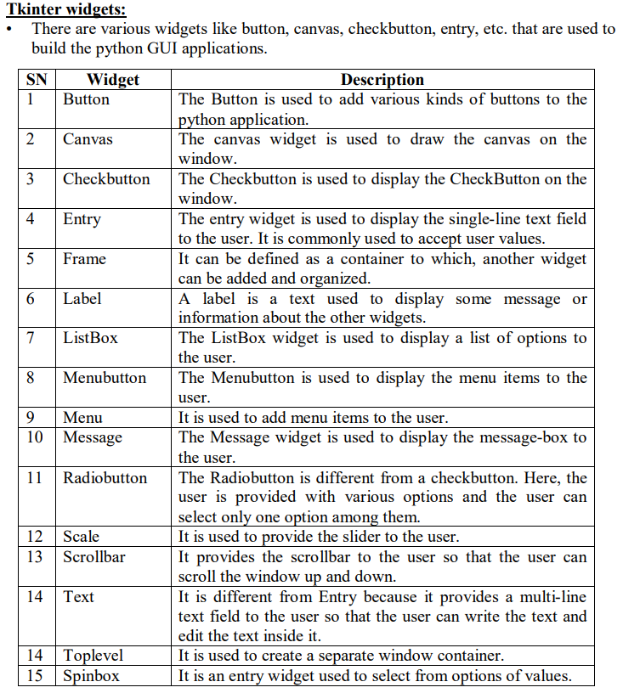

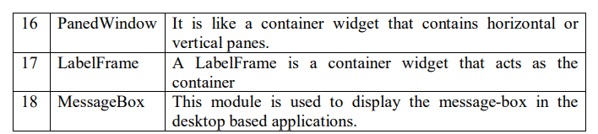

**11)explain tkinter place() method**

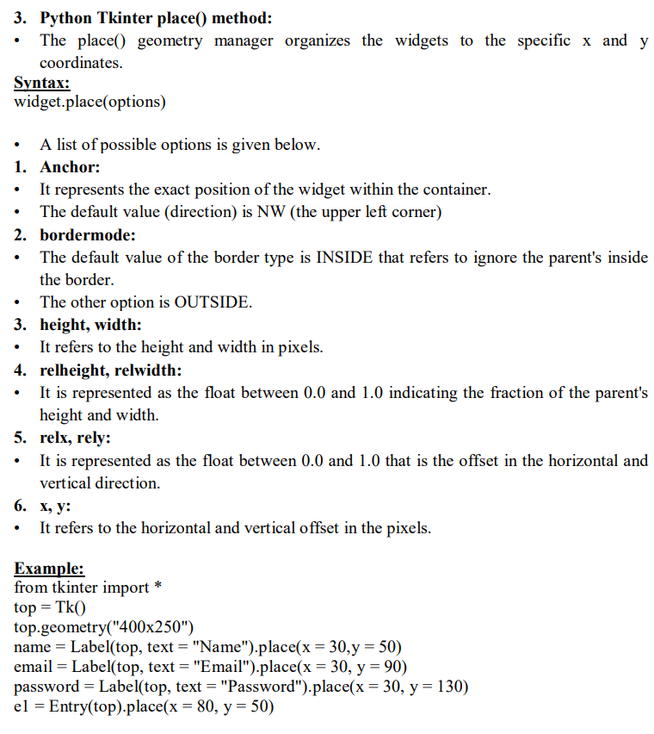

**12)Explain tkinter grid()**

**🡪**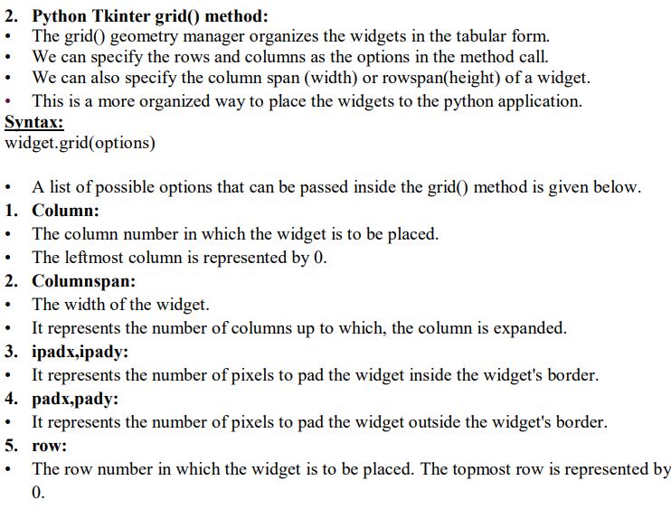

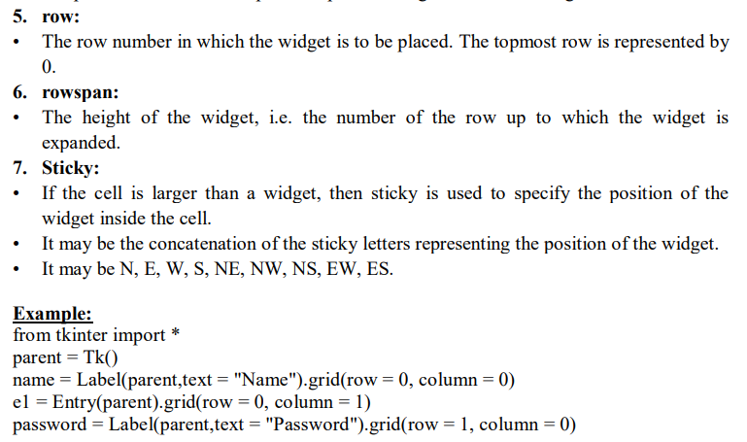

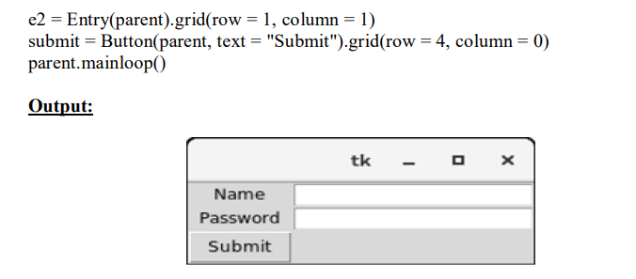

**13)Explain tkinter text and frame with Exmple.**

**🡪**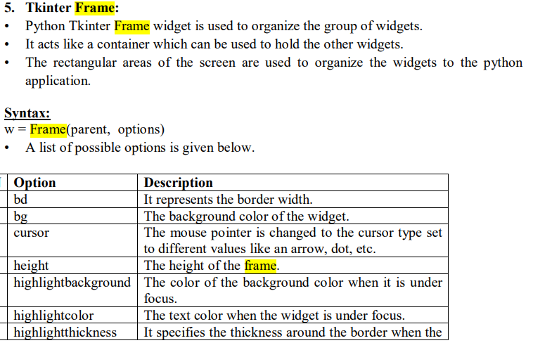

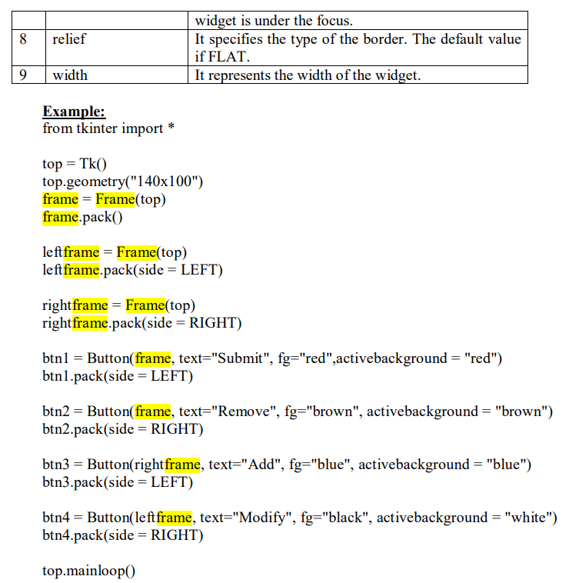

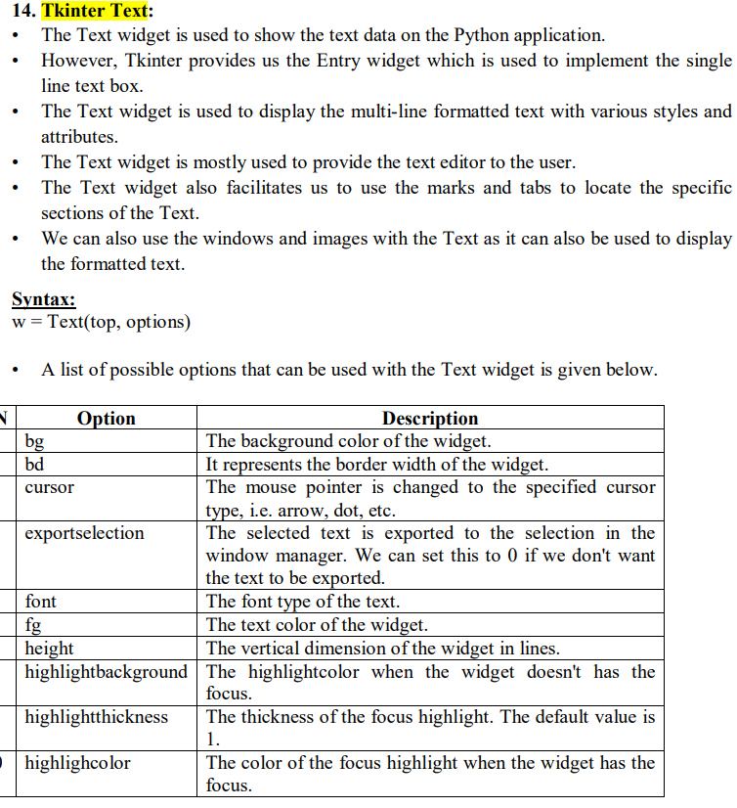

**14)Explain tkinter buton with example**

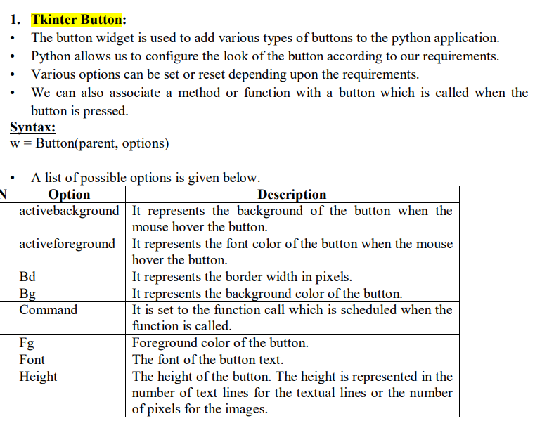

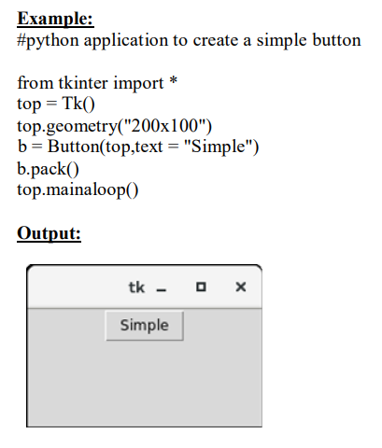

**15)Expalin labelframe with example**

**🡪**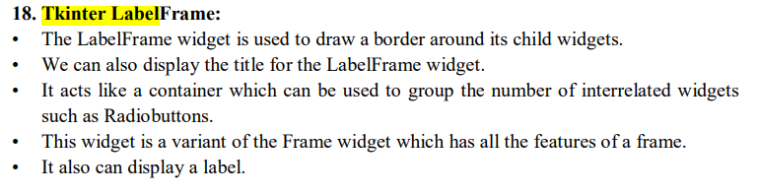

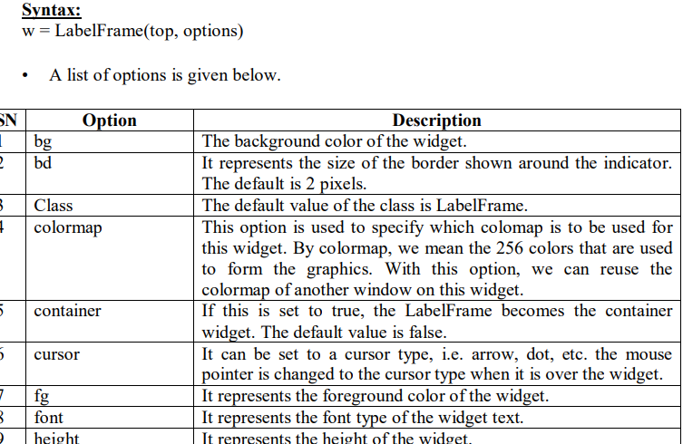

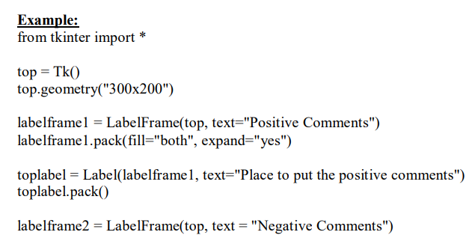

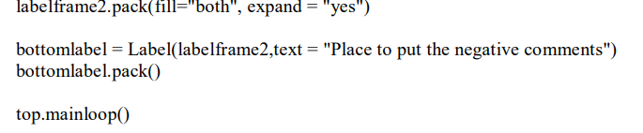

**15)list various method in menu widget.**

**🡪**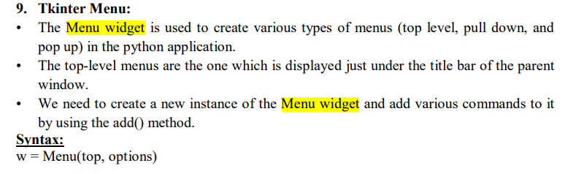

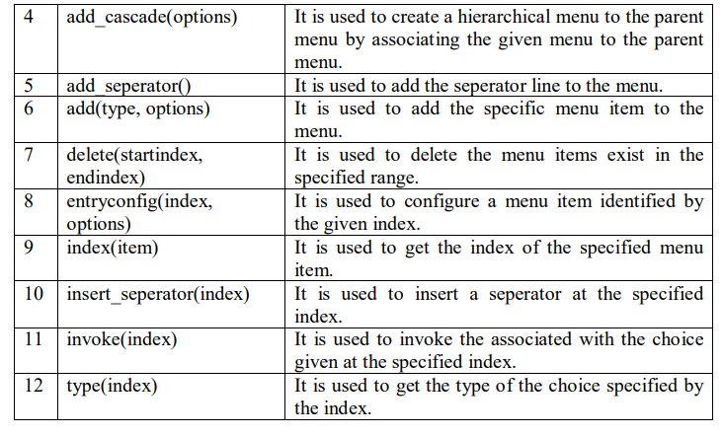

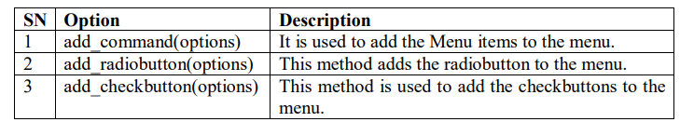

**16)Explain tkinter canvas with example**

**🡪**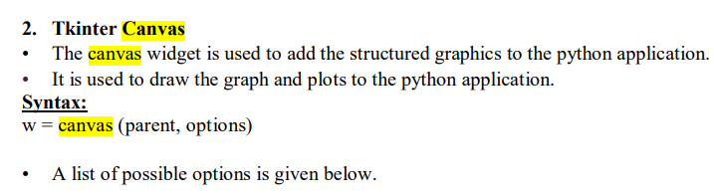

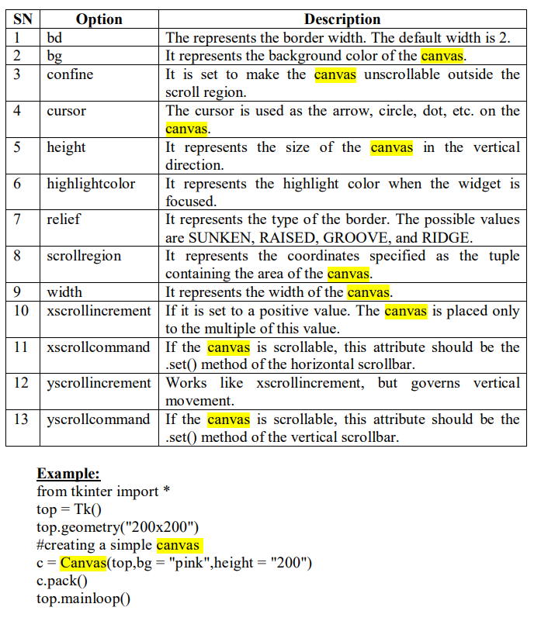

**17)Expali tkinter massagebox**

**🡪**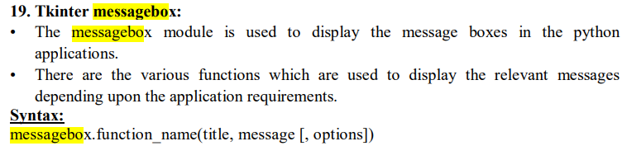

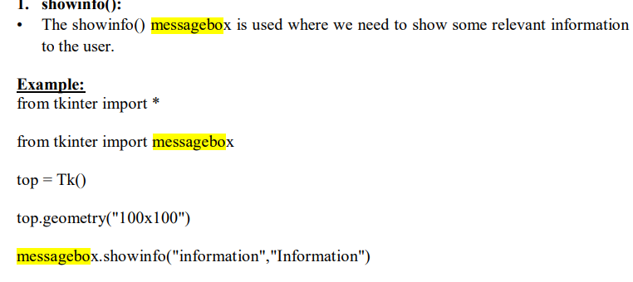

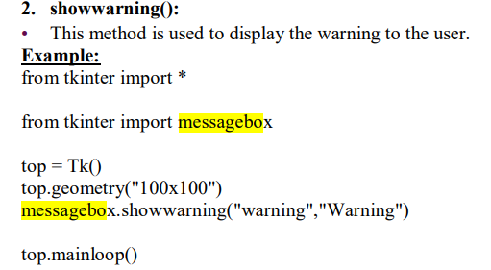

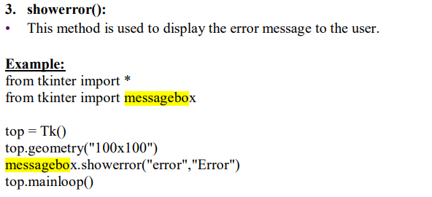

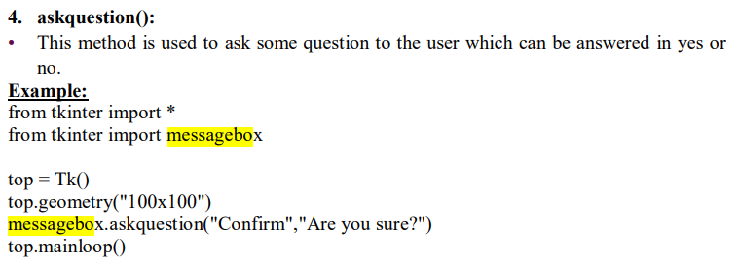

**18)Explain redio button with example**

**🡪**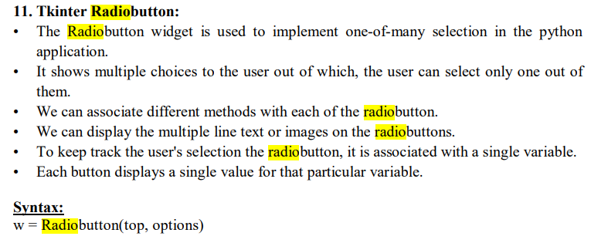

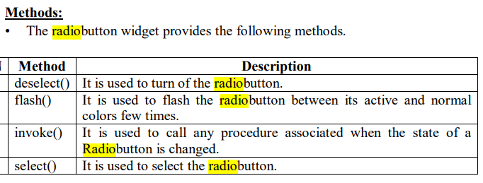

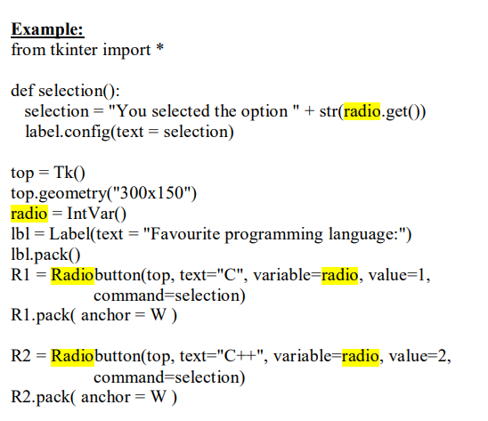

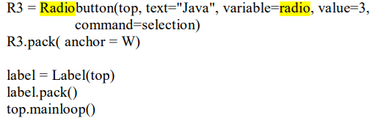

**19)**

UNIT-2

**1)numpy stand for NUMERICAL python**

**2)numpy performance array oriented(true/false)**

**3)ndarray stand for** N-dimensional array

**4)numpy was created by**Travis Oliphant

**5)numpy contains a matrix library**  numpy. matlib

**6)which function is used to calculate the middle element of date?==mid()**

**7)what is numpy? How it is useful?**

**🡪**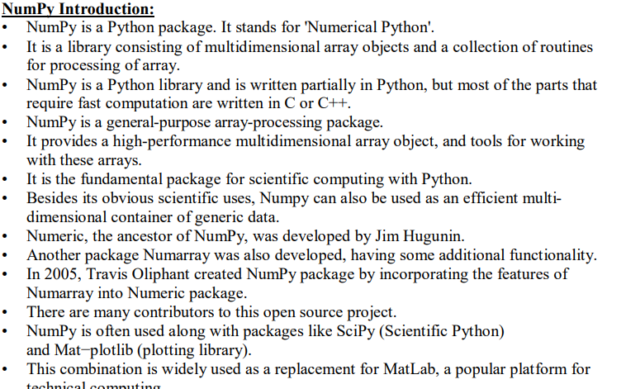

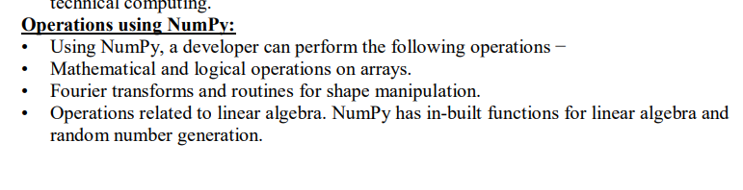

**8)what is Ndarry?describe its dimension**

**🡪**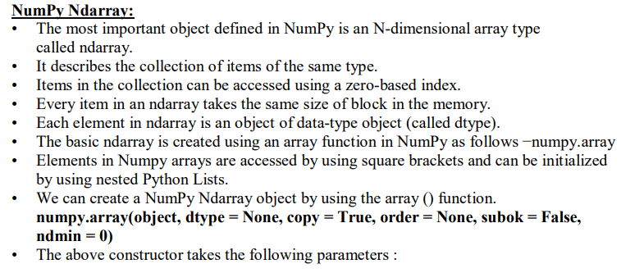

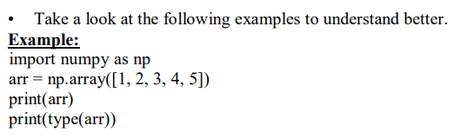

**9)Explain multiply(), title(), join() of Numpy**

**🡪**

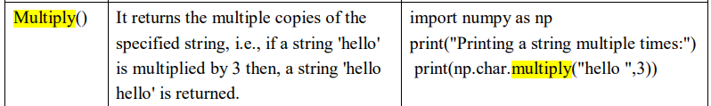

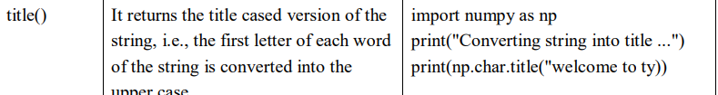

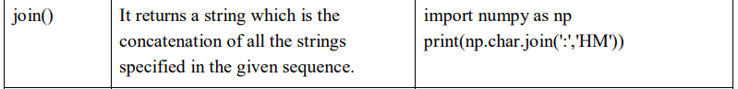

**10)different copies and views**

**🡪**The main difference between a copy and a view of an array is that the copy is a new array, and the view is just a view of the original array.

The copy *owns* the data and any changes made to the copy will not affect original array, and any changes made to the original array will not affect the copy.

The view *does not own* the data and any changes made to the view will affect the original array, and any changes made to the original array will affect the view.

**Copy:**

import numpy as np  
  
arr = np.array([1, 2, 3, 4, 5])  
x = arr.copy()  
arr[0] = 42  
  
print(arr)  
print(x)

The copy SHOULD NOT be affected by the changes made to the original array.

**View:**

import numpy as np  
  
arr = np.array([1, 2, 3, 4, 5])  
x = arr.view()  
arr[0] = 42  
  
print(arr)  
print(x)

The view SHOULD be affected by the changes made to the original array.

**11)Explain numpy datatypes.**

**🡪**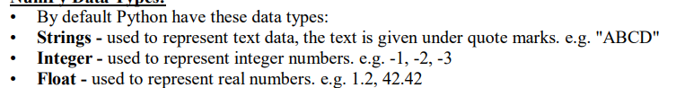



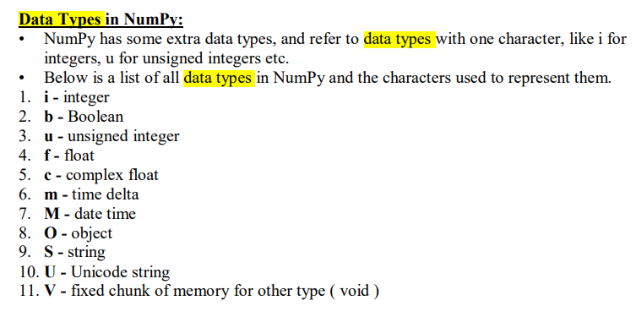

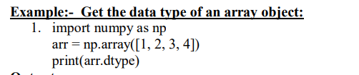

**12)Expalin numpy broadcasting**

**🡪**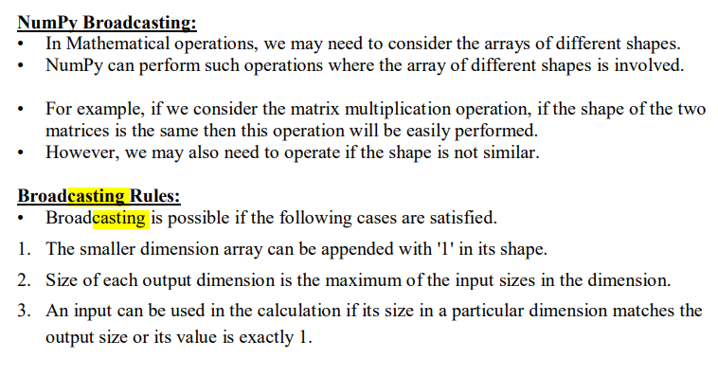

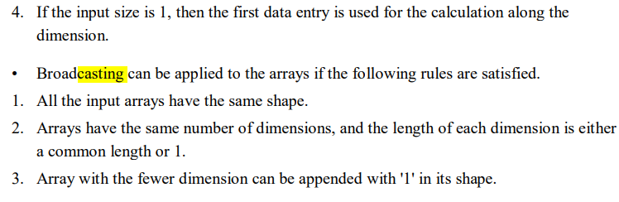

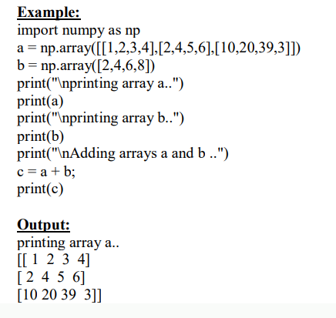

**13)Explain mathematical functions**

**🡪**Numpy contains a large number of mathematical functions which can be used to perform various mathematical operations. The mathematical functions include trigonometric functions, arithmetic functions, and functions for handling complex numbers.

**1. Trigonometric Functions**

NumPy provides a set of standard trigonometric functions to calculate the trigonometric ratios (sine, cosine, tangent, etc.)

Here's a list of commonly used trigonometric functions in NumPy.

|  |  |
| --- | --- |
| Trigonometric Function | Computes (in radians) |
| sin() | the sine of an angle |
| cos() | cosine of an angle |
| tan() | tangent of an angle |
| arcsin() | the inverse sine |
| arccos() | the inverse cosine |
| arctan() | the inverse tangent |
| degrees() | converts an angle in radians to degrees |
| radians() | converts an angle in degrees to radians |

Let's see the examples.

import numpy as np

# array of angles in radians

angles = np.array([0, 1, 2])

print("Angles:", angles)

# compute the sine of the angles

sine_values = np.sin(angles)

print("Sine values:", sine_values)

# compute the inverse sine of the angles

inverse_sine = np.arcsin(angles)

print("Inverse Sine values:", inverse_sine)

**2. Arithmetic Functions**

NumPy provides a wide range of arithmetic functions to perform on arrays.

Here's a list of various arithmetic functions along with their associated operators:

|  |  |  |
| --- | --- | --- |
| Operation | Arithmetic Function | Operator |
| Addition | add() | + |
| Subtraction | subtract() | - |
| Multiplication | multiply() | * |
| Division | divide() | / |
| Exponentiation | power() | ** |
| Modulus | mod() | % |

Let's see the examples.

import numpy as np

first_array = np.array([1, 3, 5, 7])

second_array = np.array([2, 4, 6, 8])

# using the add() function

result2 = np.add(first_array, second_array)

print("Using the add() function:",result2)

**3. Rounding Functions**

We use rounding functions to round the values in an array to a specified number of decimal places.

Here's a list of commonly used NumPy rounding functions:

|  |  |
| --- | --- |
| Rounding Functions | Functions |
| round() | returns the value rounded to the desired precision |
| floor() | returns the values of array down to the nearest integer that is less than each element |
| ceil() | returns the values of array up to the nearest integer that is greater than each element. |

Let's see an example.

import numpy as np

numbers = np.array([1.23456, 2.34567, 3.45678, 4.56789])

# round the array to two decimal places

rounded_array = np.round(numbers, 2)

print(rounded_array)

# Output: [1.23 2.35 3.46 4.57]

**14)Explin betwise operator**

**🡪**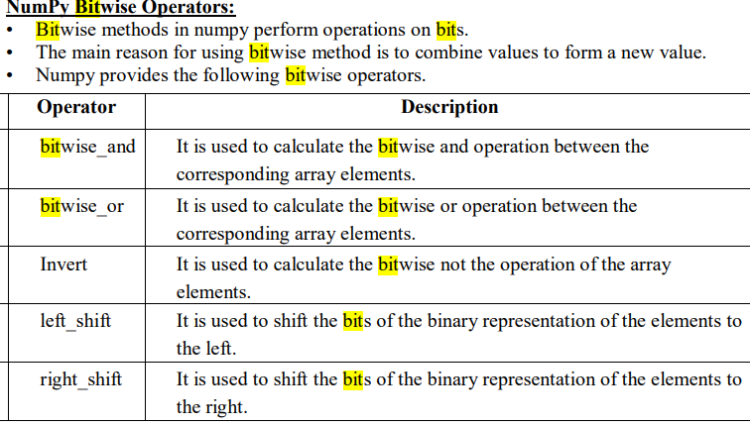

**15)Explain numpy Linear algebra with example**

**🡪**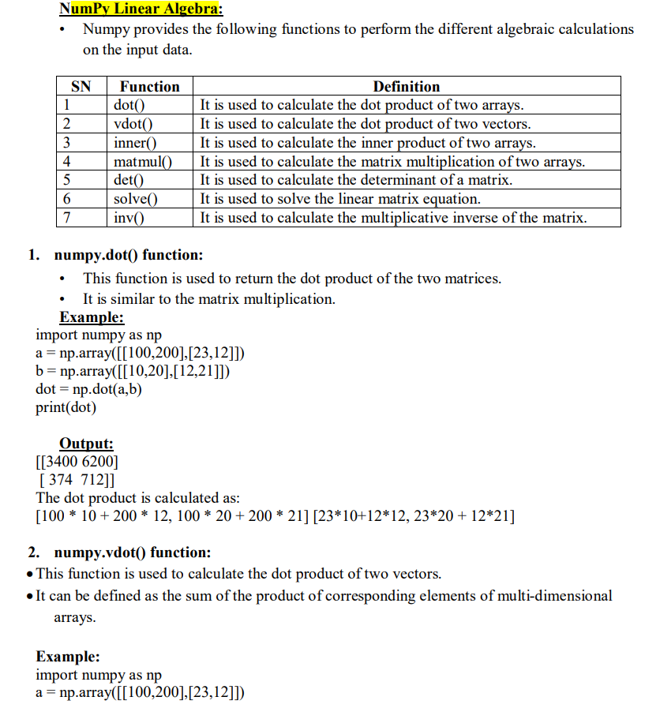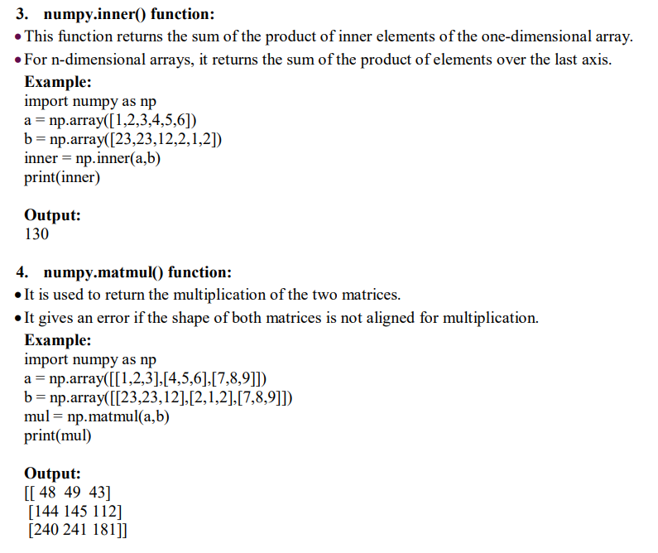

**16)Explain sorting and searching in numpy array with example**

**🡪**Sorting means putting elements in an *ordered sequence*.

*Ordered sequence* is any sequence that has an order corresponding to elements, like numeric or alphabetical, ascending or descending.

The NumPy ndarray object has a function called sort(), that will sort a specified array.

Exampl:

Sort the array:

import numpy as np  
  
arr = np.array([3, 2, 0, 1])  
  
print(np.sort(arr))

import numpy as np  
  
arr = np.array(['banana', 'cherry', 'apple'])  
  
print(np.sort(arr))

**17)Explain with example : title(), lower(), upper()**

**🡪**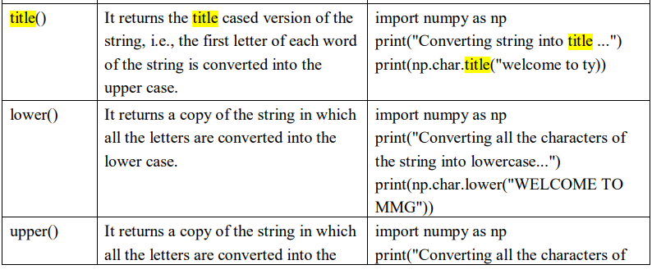

**18)**

**UNIT-3**

**1)__method I use to achive lock.**

**2)_____method runs automatically when start() called.**

**3)if you to install pylab you must also install ________--**

**4)______is used to make some changes to figure.**

**5)________plot is type of plot that shows the data as a collection of points.**

**6)what is PyLab?**

**🡪**PyLab is a Python standard library module that provides many of the facilities of MATLAB, “a high- level technical computing language and interactive environment for algorithm development, data visualization, data analysis, and numeric computation

**7)plot can be saving in file using____**

**8)________method adds item to a multithreded queue.**

**9)Explain MatPlotlib method.**

**🡪**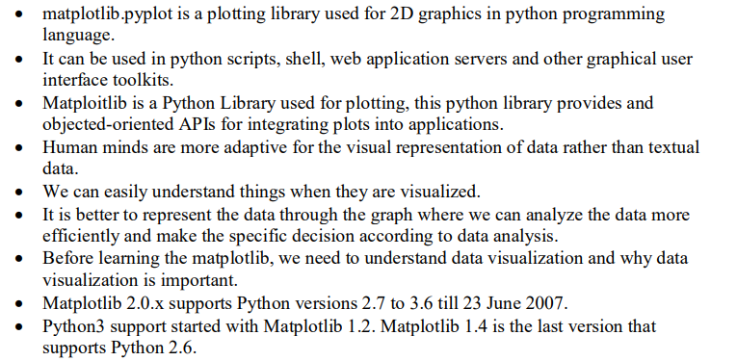

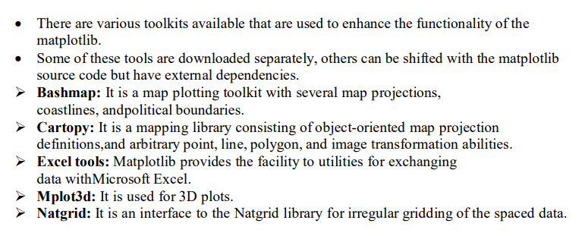

**10)Explain Synchronizing thread.**

**🡪** 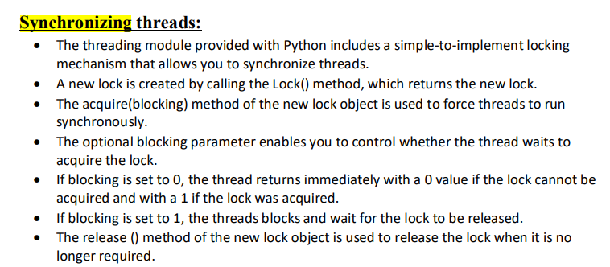

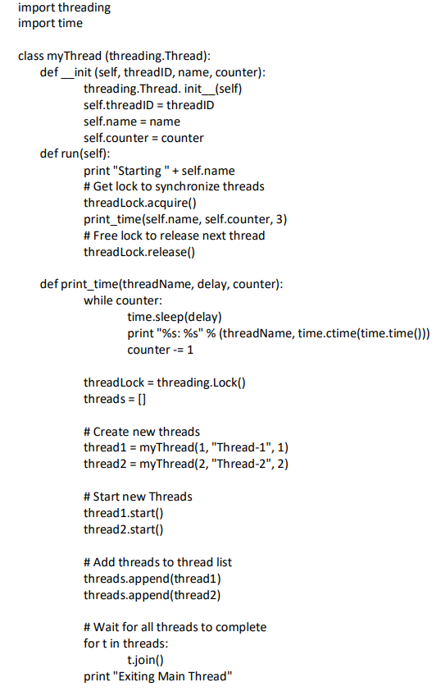

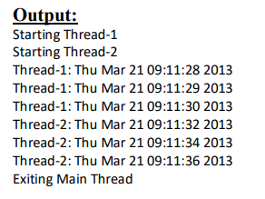

**11)Difference between python multithreading and multiprocessing**

**🡪**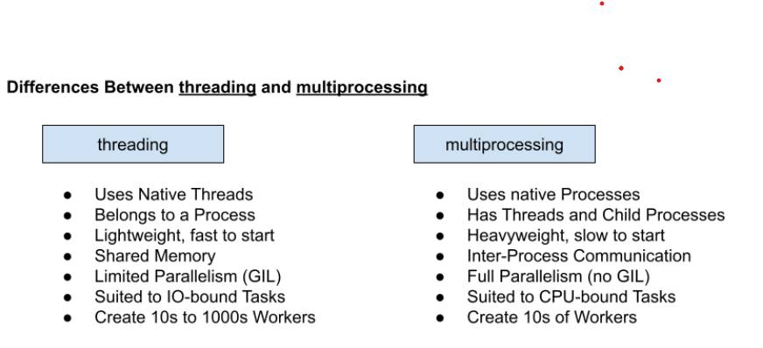

**12)Expalin thread method in details. Or Explan threading with Example.**

**🡪** 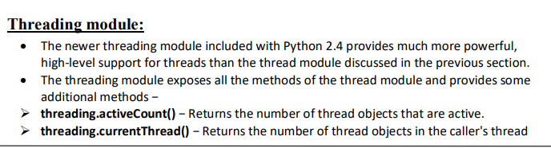

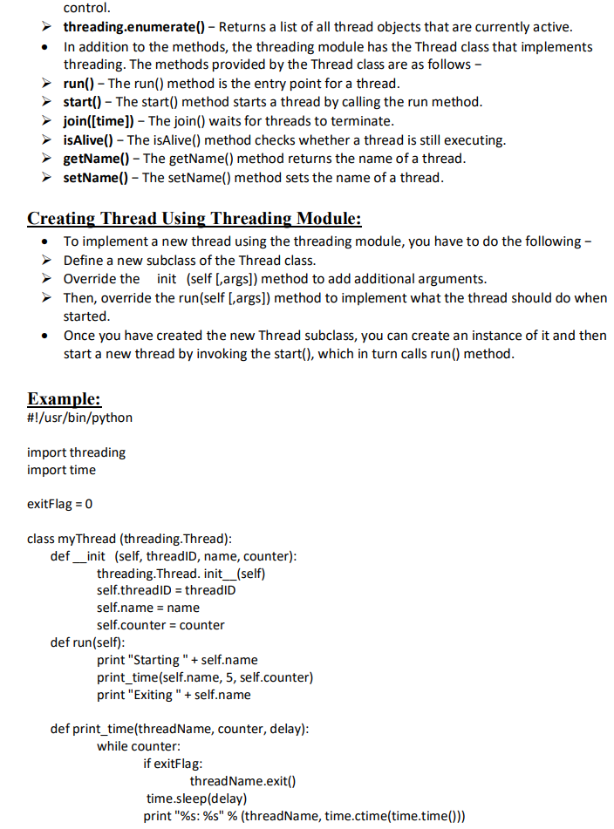

**-**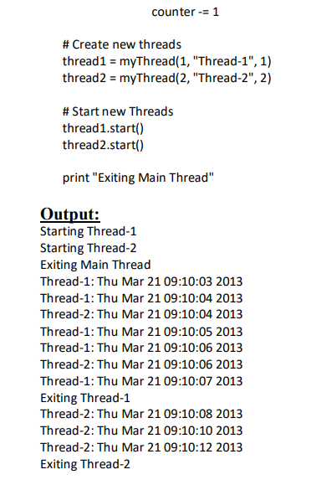

**13)Explain PyLab Bar chart with Example**

**🡪** A bar plot or bar chart is a graph that represents the category of data with rectangular bars with lengths and heights that is proportional to the values which they represent. The bar plots can be plotted horizontally or vertically. A bar chart describes the comparisons between the discrete categories. One of the axis of the plot represents the specific categories being compared, while the other axis represents the measured values corresponding to those categories.

The matplotlib API in Python provides the bar() function which can be used in MATLAB style use or as an object-oriented API. The syntax of the bar() function to be used with the axes is as follows:-

plt.bar(x, height, width, bottom, align)

The function creates a bar plot bounded with a rectangle depending on the given parameters. Following is a simple example of the bar plot, which represents the number of students enrolled in different courses of an institute.

import numpy as np

import matplotlib.pyplot as plt

data = {'C':20, 'C++':15, 'Java':30,

        'Python':35}

courses = list(data.keys())

values = list(data.values())

fig = plt.figure(figsize = (10, 5))

plt.bar(courses, values, color ='maroon',

        width = 0.4)

plt.xlabel("Courses offered")

plt.ylabel("No. of students enrolled")

plt.title("Students enrolled in different courses")

plt.show()

14)Ho**w can we do ploting pylab?**

**🡪** 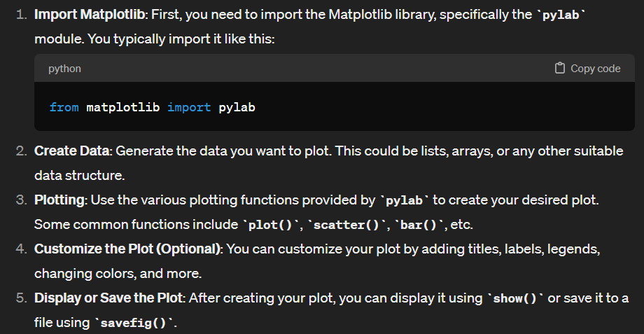

from matplotlib import pylab

x = [1, 2, 3, 4, 5]

y = [2, 3, 5, 7, 11]

pylab.plot(x, y, marker='o', linestyle='-')

pylab.title('Prime Numbers')

pylab.xlabel('Index')

pylab.ylabel('Value')

pylab.show()

**15)list all markers available in plots.**

**🡪** 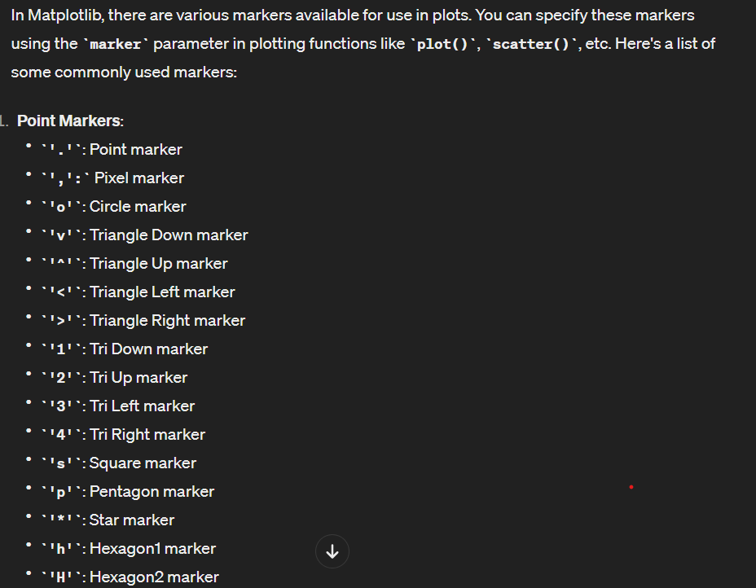

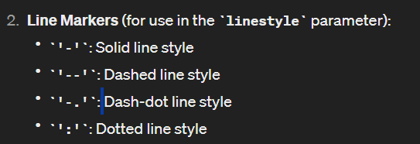

**import matplotlib.pyplot as plt**

**x = [1, 2, 3, 4, 5]**

**y = [2, 3, 5, 7, 11]**

**plt.plot(x, y, marker='o', label='Circle')**

**plt.plot(x, [i**2 for i in y], marker='s', label='Square')**

**plt.plot(x, [i**3 for i in y], marker='^', label='Triangle Up')**

**plt.legend() # Show legend with marker types**

**plt.show()**

**16)how can we start new thread?**

**🡪** 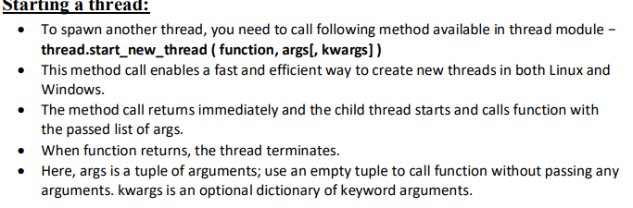

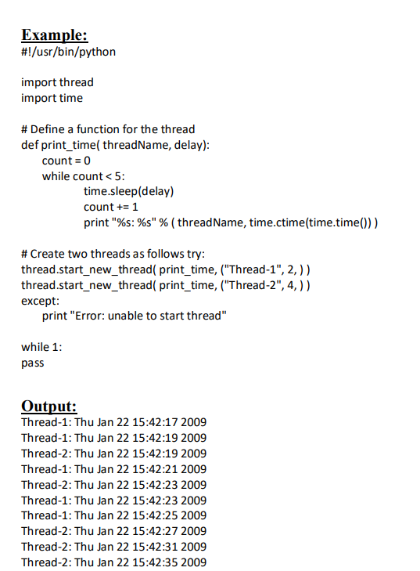

**17)**

**🡪**

Unit -4

1)Django is automatically creates a________ database for your projects.

2)by default ____file is used as a Django setting file.

3)______module is used to connect pyton application with the mysql.

4)____methos is use to create database cobbection in mysql with python.

5)**fetch one** method is uses to single record from the database.

6)_______method is use to close current cursor object.

7)write steps to python program that interect with a mysql based database.

🡪 Install pip mysqlclient.

Import pymysql as MySQLdb.

Open database connection.

Prepare a cursor object using cursor()

Execute SQL query using execute ()

Fetch a single row using fetchone ()

Disconnect from server.

8)how to create connection with database in python? Or create database

🡪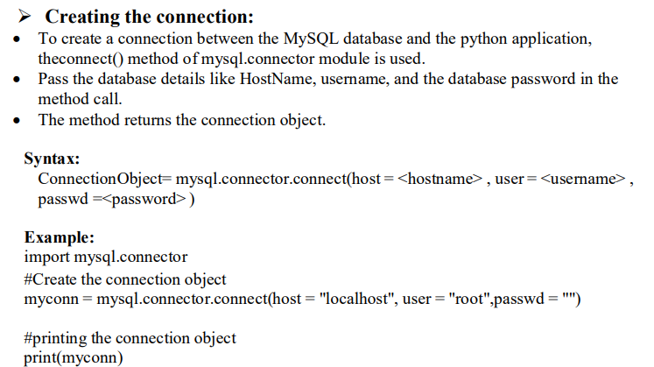

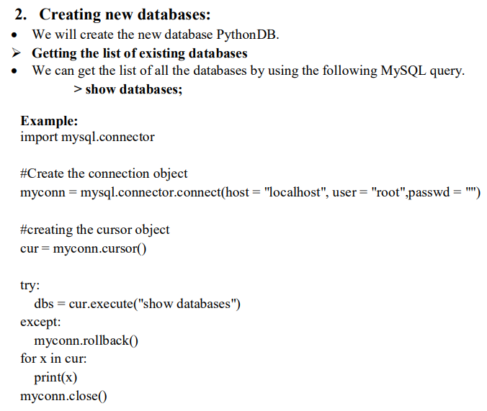

9)how can we delete object from the database in python?

🡪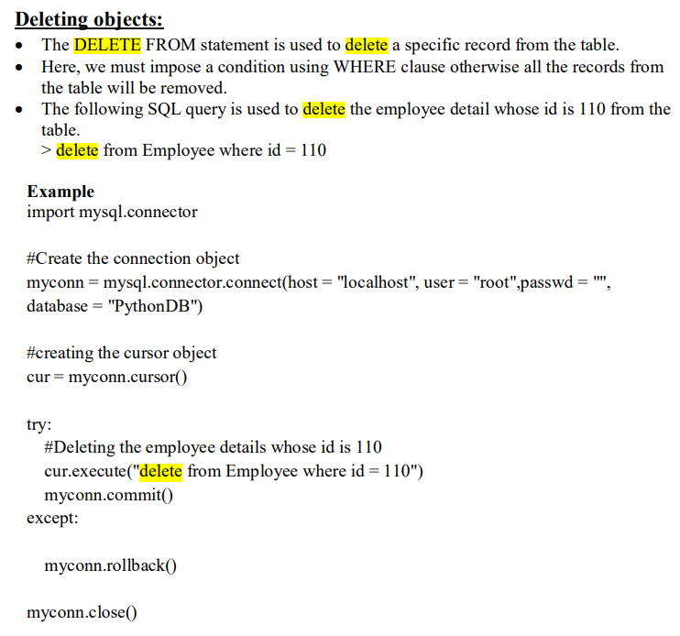

10)write code insert and update data .

🡪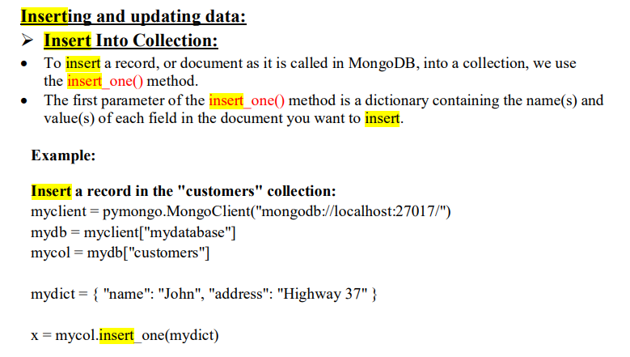

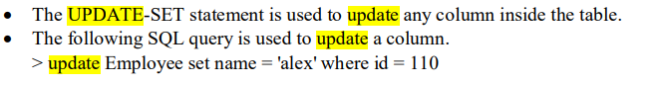

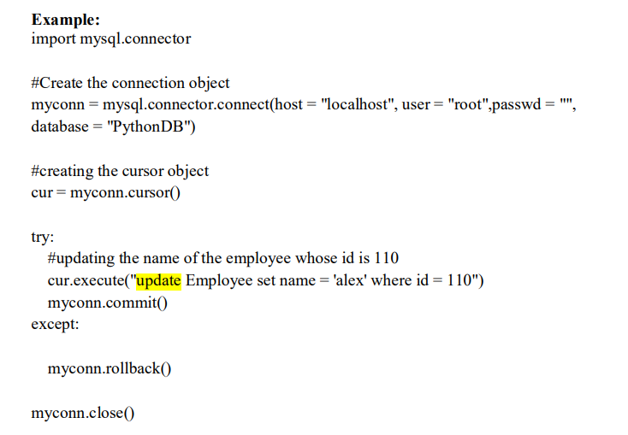

11)Explain model class and variable

🡺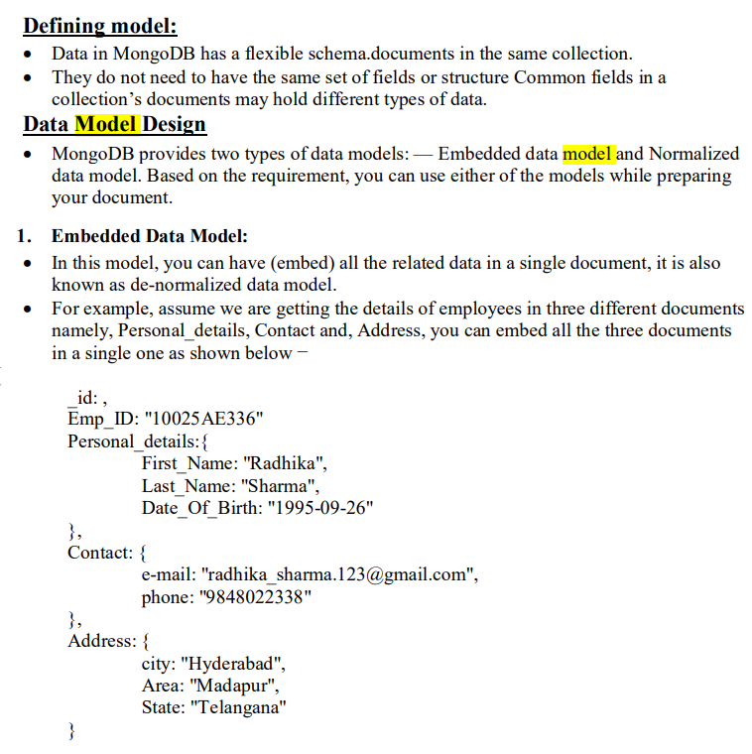

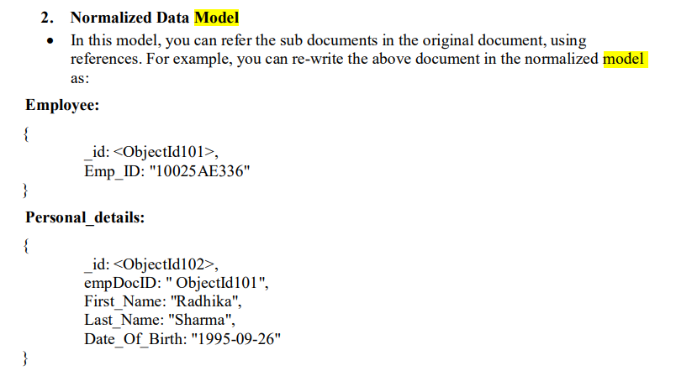

12)Explain database field.

🡪 Field types

Each field in the model should be an instance of the appropriate Field class. Django uses field class types to determine a few things:

The column type, which tells the database what kind of data to store (e.g. INTEGER, VARCHAR, TEXT).

The default HTML widget to use when rendering a form field (e.g. <input type=”text”>, <select>).

The minimal validation requirements, used in Django’s admin and in automatically-generated forms.

Django ships with dozens of built-in field types which can be used to save any type of data from number to entire HTML file too. Here is a list of all Field types used in Django.

Django also defines a set of fields that represent relations.

| **Field Name** | **Description** |
| --- | --- |
| [ForeignKey](https://www.geeksforgeeks.org/python-relational-fields-in-django-models/) | A many-to-one relationship. Requires two positional arguments: the class to which the model is related and the on_delete option. |
| [ManyToManyField](https://www.geeksforgeeks.org/python-relational-fields-in-django-models/) | A many-to-many relationship. Requires a positional argument: the class to which the model is related, which works exactly the same as it does for ForeignKey, including recursive and lazy relationships. |
| [OneToOneField](https://www.geeksforgeeks.org/python-relational-fields-in-django-models/) | A one-to-one relationship. Conceptually, this is similar to a ForeignKey with unique=True, but the “reverse” side of the relation will directly return a single object. |

13)**Explain database configuration Django with sqlite.**

🡪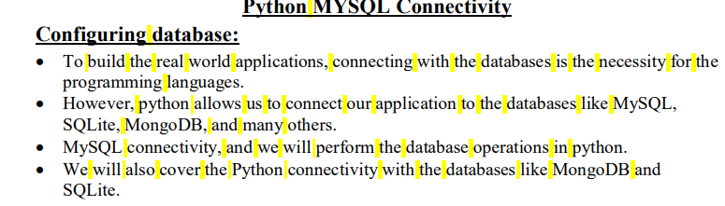

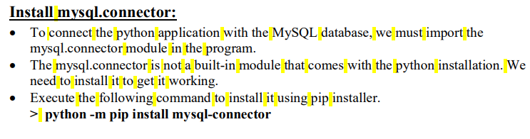

14)Explain get() and filter() method.

🡪 The get() Method

The get() method is a specialised querying technique in Django’s QuerySets this is used to retrieve a single item from the database that matches positive standards. It is specially beneficial whilst you anticipate best one result, and it has some wonderful characteristics:

Returns a Single Object: The get() technique returns exactly one item that matches the desired query situations. If more than one gadgets meet the criteria or no objects are determined, Django raises a ‘MultipleObjectsReturned’ or ‘DoesNotExist’ exception, respectively.

Exception Handling: It is vital to deal with exceptions while the use of the get() approach, as they are raised in cases in which the query conditions do no longer suit any objects or while a couple of items suit. Proper exception handling ensures that your utility behaves gracefully even when unexpected situations occur.

Using get() method to fetch data

In this example, we attempt to retrieve a book with the title “The Great Gatsby”. If a book with this title exists, the book variable will contain the retrieved object. If no book matches the query, a ‘Book.DoesNotExist’ exception is raised, which we handle gracefully. Similarly, if multiple books have the same title, a ‘Book.MultipleObjectsReturned’ exception is raised.

from myapp.models import Book

try:

book = Book.objects.get(title='The Great Gatsby')

except Book.DoesNotExist:

except Book.MultipleObjectsReturned:

**Filter()**

The filter() method is used to filter your search, and allows you to return only the rows that matches the search term.

mydata = Member.objects.filter(firstname='Emil').values()

The filter() method takes the arguments as **kwargs (keyword arguments), so you can filter on more than one field by separating them by a comma.

Example

Return records where lastname is "Refsnes" and id is 2:

mydata = Member.objects.filter(lastname='Refsnes', id=2).values()

15)Explain Basic data access in details.

🡪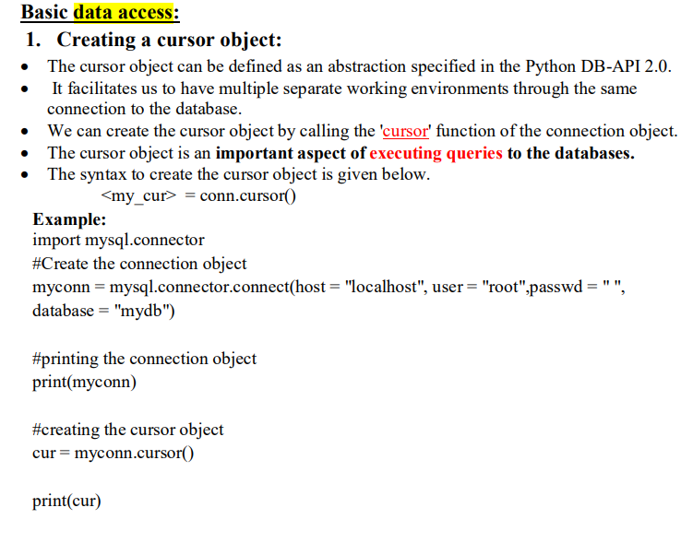

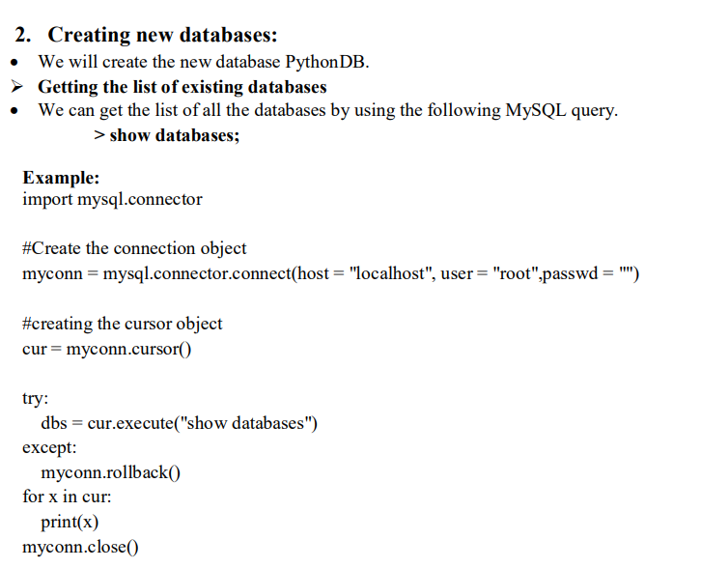

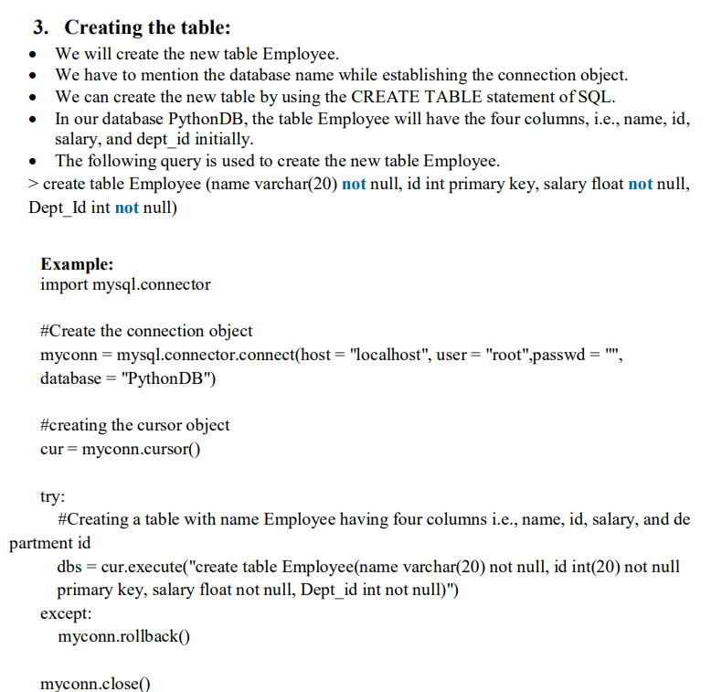

16)

UNIT-5

1)WAF=

2)MVC=Model view controller

3)When a page is request , Django create__oblect

4)MVT=Model View Template

5)____file is run to activate environment for Django project

6)Which file is used to interact with your Django project via the command LINE?

7)what is Djnago ? how it is useful? And features of Django

🡪

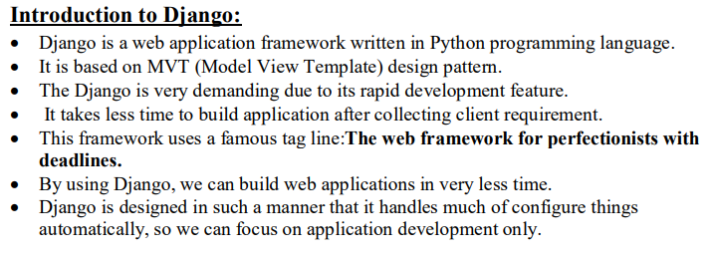

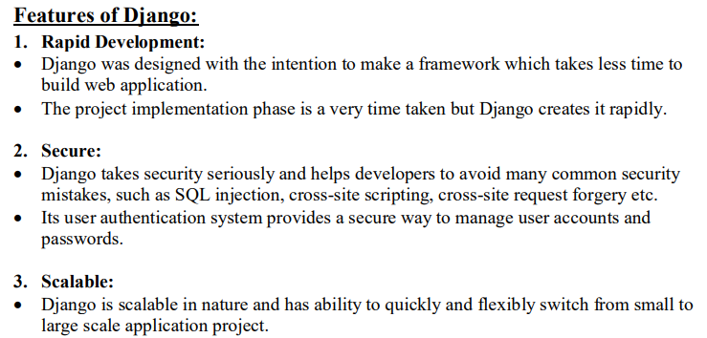

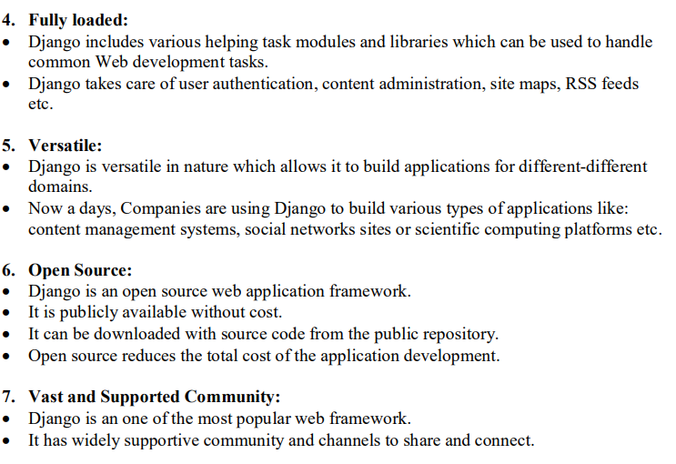

8)write steps to installation Django .

🡪 Install Python.

Install Apache and mod_wsgi.

Get your database running.

Install the Django code. Installing an official release with pip. Installing a distribution-specific package. Installing the development version.

9)Discuss HttpRequest class.

🡪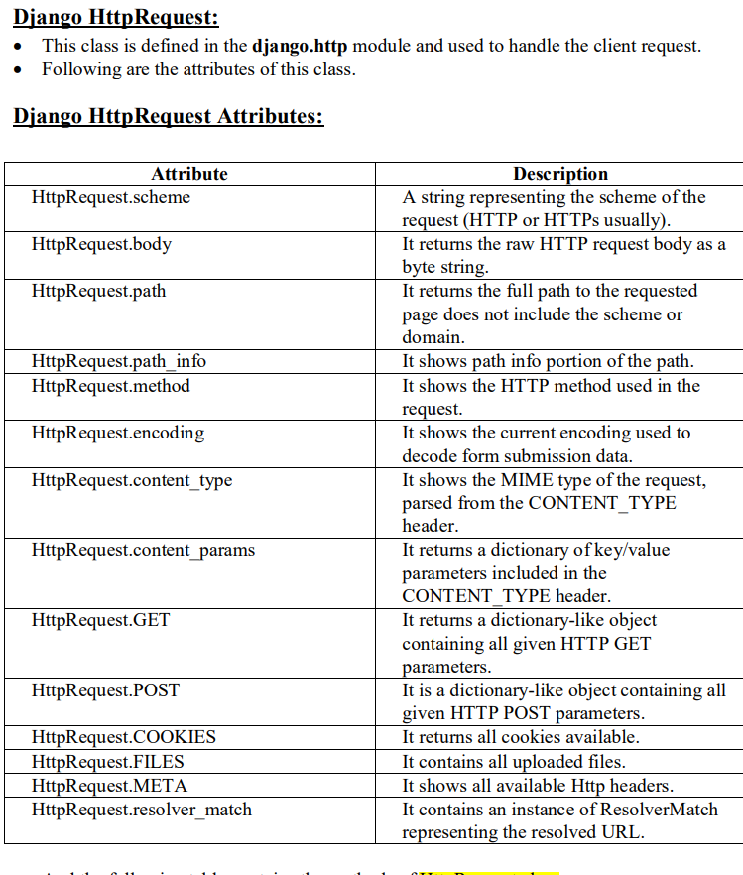

10)Explain MVC Design pattern.

🡪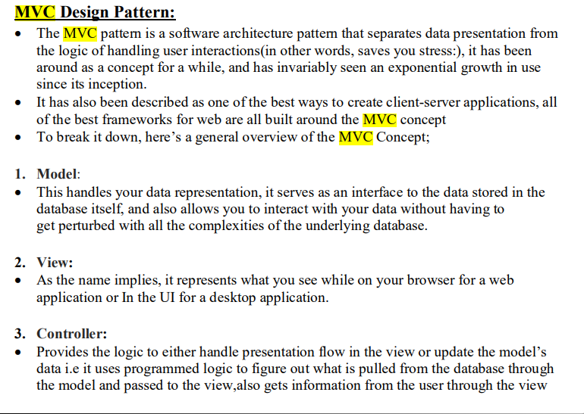

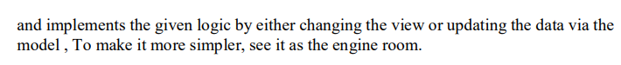

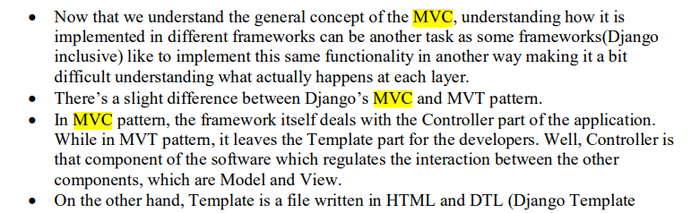

11)Explain Django Project Architecture.

🡪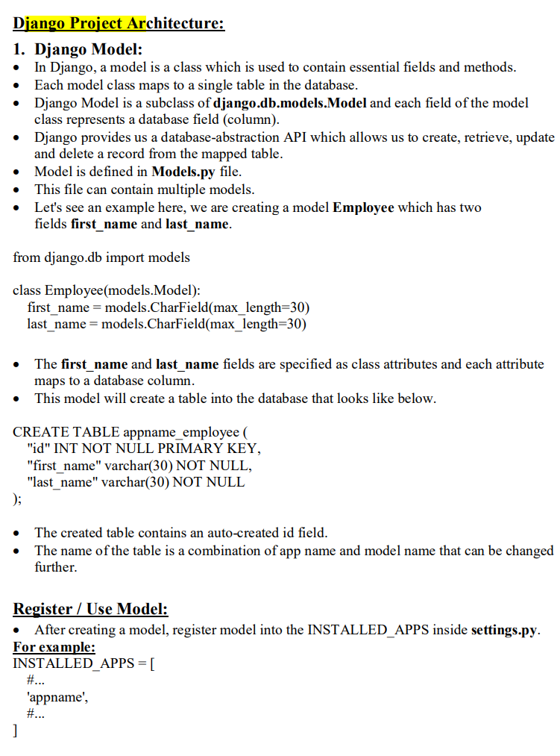

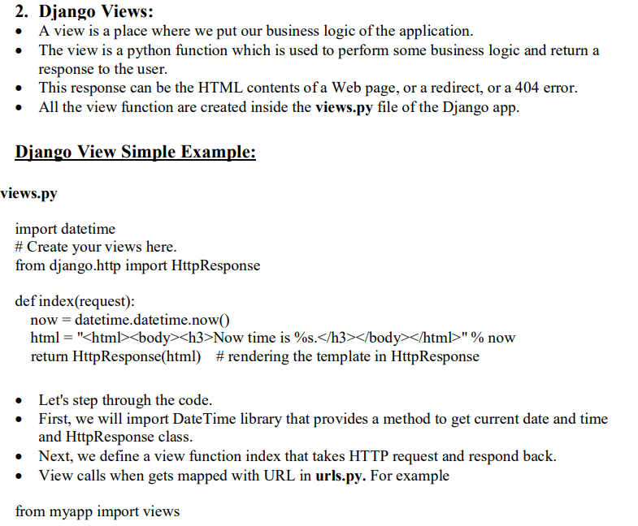

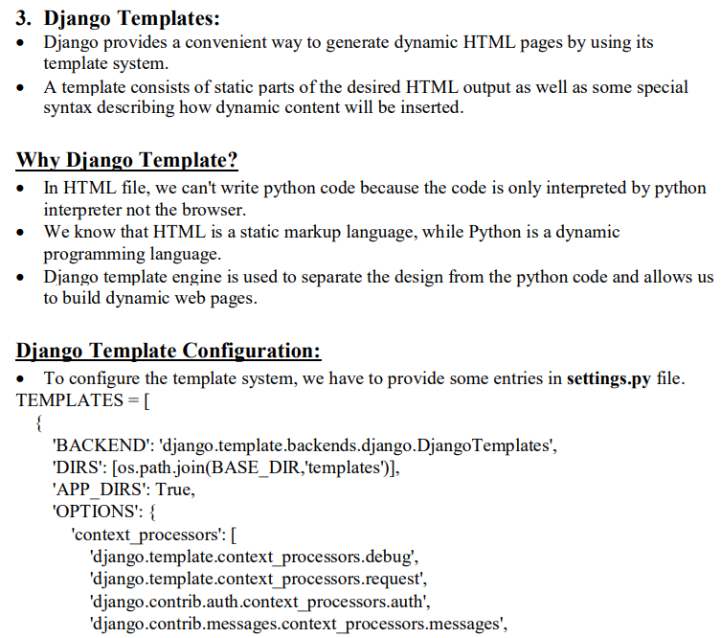

12)Explain advantages of Django

🡪 Scalable

Security

Community support

Admin GUI

Django is simple

Faster development

Batteries Included

Versatile

Better api frameworks

Documentation

Fast

Fully Loaded

Not suitable for smaller projects

REST Framework

Secure

Session handling

URL routing

Ajax

Authentication

Django is highly secure

Django offers rapid development

Dry and kiss compliant

Easy to learn

13)What is MVT architecture?

🡪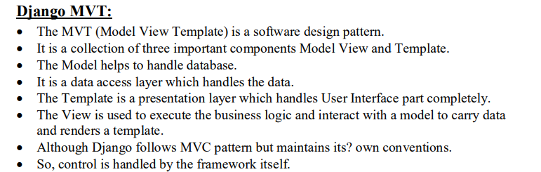

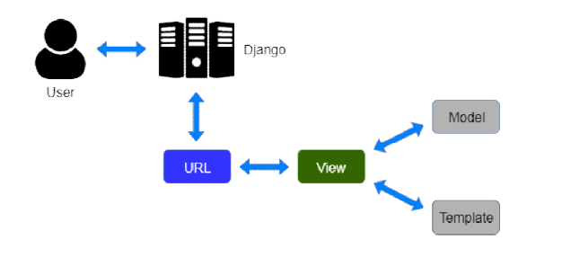

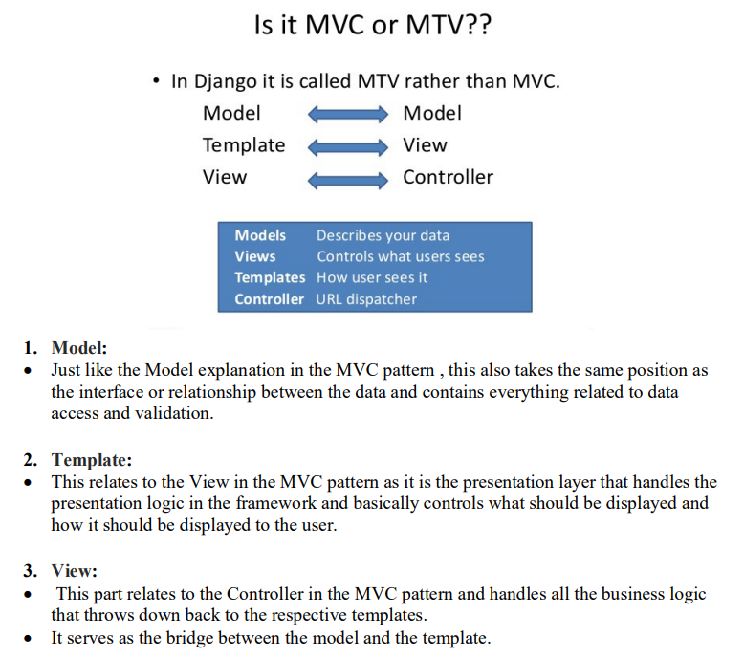

13)Explain request-response cycle.

🡪   
Django’s request-response cycle is a fundamental concept that outlines how the Django web framework processes incoming HTTP requests and generates corresponding HTTP responses. This cycle is the core mechanism through which Django handles client interactions and serves web applications. Here’s an explanation of Django’s request-response cycle:

1. **Client Request:** The cycle begins when a client (usually a web browser) sends an HTTP request to a Django-powered web server. The request includes important information such as the requested URL, HTTP method (e.g., GET, POST), headers, and any data sent in the request body (e.g., form data).

1. **URL Routing:** Django’s URL dispatcher, configured in your project’s `urls.py` file, plays a central role. It examines the incoming request’s URL to determine which view function should handle the request. The URL dispatcher uses regular expressions or path converters to map URLs to view functions.

1. **View Function Processing:** Once the URL dispatcher identifies the appropriate view function, it calls that function, passing the HTTP request as its argument. The view function contains the application’s logic, processing the request, interacting with models and databases, and preparing data for the response.

1. **Response Preparation:** After processing, the view function constructs an HTTP response object. This response object includes the content to be sent back to the client, such as HTML content, JSON data, or binary files. You can also set response headers, cookies, and status codes within the response object.

1. **Middleware Execution:** Before the response is sent back to the client, Django’s middleware is executed. Middleware are functions or classes that can perform actions such as authentication, request/response modification, logging, and more. Middleware can either process the request before it reaches the view function or the response before it leaves the server.

1. **Sending the Response**: Finally, the HTTP response is sent back to the client over the network. The client’s web browser processes the response, rendering HTML content, executing JavaScript, and displaying the web page. If the response includes data, the client may also use that data for further interaction or rendering.

1. **Repeat or Terminate:** The request-response cycle repeats whenever the client interacts with the web application by sending additional requests. The cycle can continue as long as the client interacts with the application. When the client no longer needs to communicate with the server, the request-response cycle for that interaction terminates.

Django’s request-response cycle is the foundational process that drives the interaction between clients and web applications built using Django. It orchestrates the handling of incoming requests, routing them to the appropriate view functions, processing and preparing responses, and ultimately sending those responses back to the client, making it a fundamental concept to understand when working with Django

14)Create view using Django..

🡪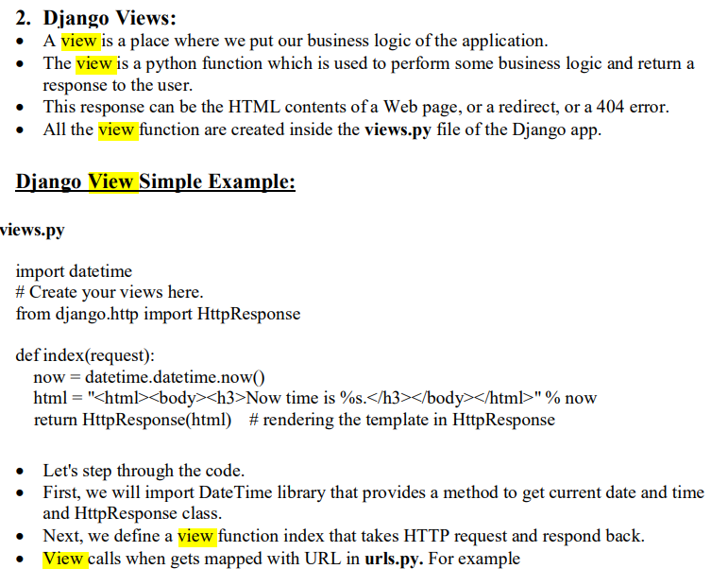

15)djnago basic template filter.

🡪Django Template Engine provides filters which are used to transform the values of variables and tag arguments. We have already discussed major [Django Template Tags](https://geeksforgeeks.org/django-template-tags/). Tags can’t modify value of a variable whereas filters can be used for incrementing value of a variable or modifying it to one’s own need.

Syntax

{{ variable_name | filter_name }}

Filters can be “chained.” The output of one filter is applied to the next. {{ text|escape|linebreaks }} is a common idiom for escaping text contents, then converting line breaks to <p> tags.

{{ value | length }}

If value is **[‘a’, ‘b’, ‘c’, ‘d’]**, the output will be **4**.

Basic templates filter:

🡪

|  |  |  |
| --- | --- | --- |
| [add](https://www.geeksforgeeks.org/django-template-filters/#add) | [addslashes](https://www.geeksforgeeks.org/django-template-filters/#addslashes) | [capfirst](https://www.geeksforgeeks.org/django-template-filters/#capfirst) |
| [center](https://www.geeksforgeeks.org/django-template-filters/#center) | [cut](https://www.geeksforgeeks.org/django-template-filters/#cut) | [date](https://www.geeksforgeeks.org/django-template-filters/#date) |
| [default](https://www.geeksforgeeks.org/django-template-filters/#default) | [dictsort](https://www.geeksforgeeks.org/django-template-filters/#dictsort) | [divisibleby](https://www.geeksforgeeks.org/django-template-filters/#divisibleby) |
| [escape](https://www.geeksforgeeks.org/django-template-filters/#escape) | [filesizeformat](https://www.geeksforgeeks.org/django-template-filters/#filesizeformat) | [first](https://www.geeksforgeeks.org/django-template-filters/#first) |
| [join](https://www.geeksforgeeks.org/django-template-filters/#join) | [last](https://www.geeksforgeeks.org/django-template-filters/#last) | [length](https://www.geeksforgeeks.org/django-template-filters/#length) |
| [linenumbers](https://www.geeksforgeeks.org/django-template-filters/#linenumbers) | [lower](https://www.geeksforgeeks.org/django-template-filters/#lower) | [make_list](https://www.geeksforgeeks.org/django-template-filters/#make_list) |
| [random](https://www.geeksforgeeks.org/django-template-filters/#random) | [slice](https://www.geeksforgeeks.org/django-template-filters/#slice) | [slugify](https://www.geeksforgeeks.org/django-template-filters/#slugify) |
| [time](https://www.geeksforgeeks.org/django-template-filters/#time) | [timesince](https://www.geeksforgeeks.org/django-template-filters/#timesince) | [title](https://www.geeksforgeeks.org/django-template-filters/#title) |
| [unordered_list](https://www.geeksforgeeks.org/django-template-filters/#unordered_list) | [upper](https://www.geeksforgeeks.org/django-template-filters/#upper) | [wordcount](https://www.geeksforgeeks.org/django-template-filters/#wordcount) |